Experiment 3: Implementation of Perceptron and Delta Learning Rule

AIM: To implement the perceptron learning algorithm and delta learning rule for classification tasks using supervised learning, and to study their convergence behaviour.
Problem Definition: In machine learning, classification tasks require models that can distinguish between different classes based on input features. The perceptron is one of the earliest and simplest neural network models used for binary classification. It adjusts its weights iteratively to correctly classify linearly separable data. However, for non-linearly separable data or cases requiring continuous learning, the delta learning rule (or Widrow-Hoff rule) is used as a generalized learning mechanism. Implement both learning rules and analyze their working, convergence, and limitations in learning classification boundaries.

Theory: Introduction to Perceptron: The perceptron is a fundamental unit of a neural network, functioning as a linear binary classifier. It takes multiple inputs, applies weights, sums them up, and passes the result through an activation function (usually a step function) to produce an output.
Mathematical Model: y = f(Σ (wᵢxᵢ) + b) where xᵢ represents the input, wᵢ the weight, b the bias, and f is the activation function. The output is 1 if the weighted sum exceeds a threshold, and 0 otherwise
Perceptron Learning Rule: Weights are updated based on the error between the predicted and actual output as follows: Δwᵢ = η (t - y) xᵢ where η is the learning rate, t is the target output, and y is the predicted output.
Delta Learning Rule (Widrow-Hoff Rule): The delta rule extends the perceptron learning rule by minimizing the mean squared error between the predicted and actual outputs. Unlike the perceptron rule, which updates weights only for misclassified patterns, the delta rule continuously adjusts weights using gradient descent to minimize the loss function.
Mathematical Representation: Δwᵢ = η (t - y) f'(net) xᵢ
where f'(net) is the derivative of the activation function and (t - y) is the instantaneous error.
Implementation Approach:
- Initialize weights and bias to small random values.
- Present input-output training pairs to the network.
- Compute the output using the activation function.
- Update weights according to the perceptron or delta rule.
- Repeat until the error converges or maximum epochs are reached
Comparison:
• The perceptron rule works only for linearly separable data.
• The delta rule can handle continuous outputs and non-linear activation functions.
• The delta rule forms the foundation of backpropagation in multi-layer neural networks.
Applications:
• Pattern recognition
• Binary classification problems
• Adaptive signal processing
• Foundation for deep learning
CODE:
Delta Learning Rule:
import numpy as np
import matplotlib.pyplot as plt

# --------------------- Dataset ---------------------
# XOR-like data (non-linear, continuous output learning)
X = np.array([[0,0], [0,1], [1,0], [1,1]])
y = np.array([0, 1, 1, 0]) # Expected continuous outputs

# --------------------- Delta Rule Model ---------------------
class DeltaRule:
def __init__(self, lr=0.1, epochs=200):
self.lr = lr
self.epochs = epochs
self.w = np.random.uniform(-1, 1, X.shape[1])
self.b = np.random.uniform(-1, 1)
self.mse_history = []

def fit(self, X, y):
for _ in range(self.epochs):
net = np.dot(X, self.w) + self.b
y_pred = 1 / (1 + np.exp(-net)) # Sigmoid activation
error = y - y_pred
self.w += self.lr * X.T.dot(error * y_pred * (1 - y_pred))
self.b += self.lr * np.sum(error * y_pred * (1 - y_pred))
mse = np.mean(error**2)
self.mse_history.append(mse)

def predict(self, X):
net = np.dot(X, self.w) + self.b
return 1 / (1 + np.exp(-net))

# --------------------- Training ---------------------
model = DeltaRule(lr=0.5, epochs=100)
model.fit(X, y)

# --------------------- Visualization ---------------------
plt.figure(figsize=(8,4))
plt.plot(model.mse_history, color='magenta', lw=2)
plt.title("Delta Learning Rule – MSE Convergence")
plt.xlabel("Epochs")
plt.ylabel("Mean Squared Error")
plt.grid(True)
plt.show()

# --------------------- Results ---------------------
print("Final Weights:", np.round(model.w, 3))
print("Final Bias:", round(model.b, 3))
print("Predictions:", np.round(model.predict(X), 3))

OUTPUT:
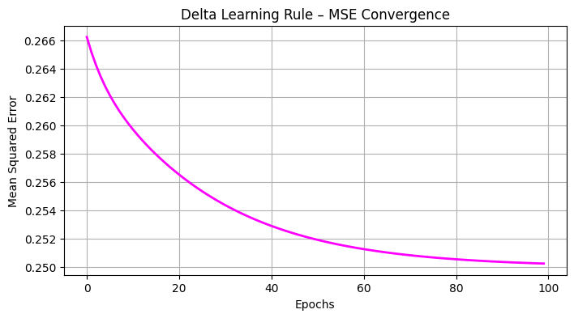
Final Weights: [0.079 0.093]
Final Bias: -0.1
Predictions: [0.475 0.498 0.495 0.518]

Perceptron Learning Rule:
import numpy as np
import matplotlib.pyplot as plt

# --------------------- Dataset ---------------------
X = np.array([[1, 1], [2, 1], [1, 2], [2, 2], [3, 3], [3, 4], [4, 3], [4, 4]])
y = np.array([0, 0, 0, 0, 1, 1, 1, 1])

# --------------------- Perceptron Class ---------------------
class Perceptron:
def __init__(self, lr=0.1, epochs=20):
self.lr = lr
self.epochs = epochs
self.w = np.zeros(X.shape[1])
self.b = 0

def activation(self, z):
return np.where(z >= 0, 1, 0)

def fit(self, X, y):
for _ in range(self.epochs):
for i in range(len(X)):
z = np.dot(X[i], self.w) + self.b
y_pred = self.activation(z)
update = self.lr * (y[i] - y_pred)
self.w += update * X[i]
self.b += update

# --------------------- Training ---------------------
model = Perceptron(lr=0.2, epochs=15)
model.fit(X, y)

# --------------------- Static Plot ---------------------
fig, ax = plt.subplots(figsize=(6, 6))
ax.set_xlim(0, 5)
ax.set_ylim(0, 5)
ax.set_title("Perceptron Final Decision Boundary")
ax.set_xlabel("Feature 1")
ax.set_ylabel("Feature 2")

# 1. Plot Scatter
ax.scatter(X[:,0], X[:,1], c=y, cmap='coolwarm', s=100, edgecolors='k')

# 2. Plot Decision Boundary Line
# Equation: w1*x1 + w2*x2 + b = 0 => x2 = -(w1*x1 + b) / w2
w = model.w
b = model.b

if w[1] != 0:
x_plot = np.array([0, 5])
y_plot = -(b + w[0] * x_plot) / w[1]
ax.plot(x_plot, y_plot, 'k--', linewidth=2, label='Decision Boundary')

ax.legend()
plt.grid(True, alpha=0.3)
plt.show()

OUTPUT:
Final Weights (w): [0.2 0.6]
Final Bias (b): -2.1999999999999997

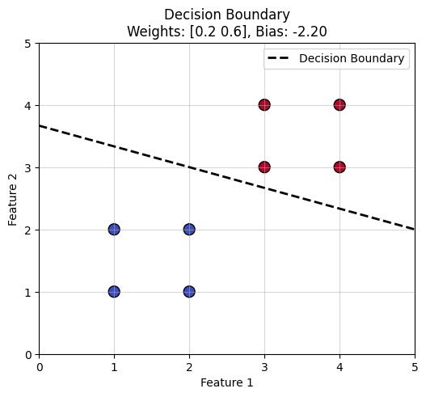

CONCLUSION:
This experiment implements the perceptron learning rule and the delta learning rule for supervised classification. It shows how both algorithms adjust weights to learn decision boundaries and demonstrates their convergence behaviour during training.

